Chapter 8 The Renaissance Vocab Terms

Aiguillettes - Debbi Wright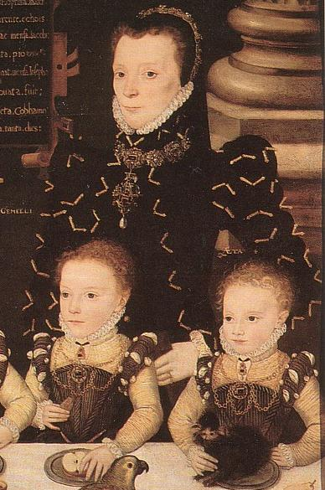

Our textbook describes aiguillettes as “small, jeweled metal points.” These can be functional or decorative. They remind me of shoe laces. During the 16th century they were used to hold panes or slashes together. It is hard to see the aiguillettes points in the first picture. In the second picture the aiguillette points are located at the bottom right corner. They were also placed on hats. In our day they are used as a decorative piece in military clothing.

Toratora, Phyllis G, and Keith Eubank. *Survey of Historic Costume, 5th Edition*. Berg, 2009.

<https://www.langantiques.com/university/aiguillette/>

<https://en.wikipedia.org/wiki/Aiguillette>

Bases - Alex Clark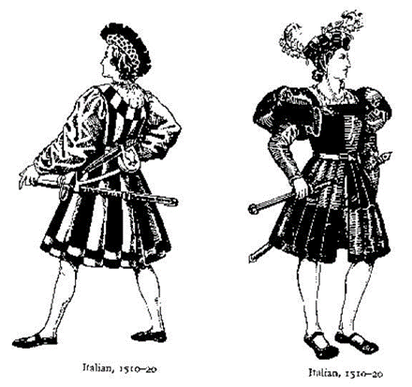

Bases was a short skirt that was separate from a jacket or doublet which were typically worn with the bases at the time. When they were worn with this combo it was either for civil dress or worn over armor for military dress. They were made up of a series of lined and stiffened gores. Bases had also been worn during the Italian Wars and it was seen on the Italians armored cavalry. The bases during the time were used as a replacement for hose and breeches.

Survey of Historic Costumes, Page 209

<https://en.wikipedia.org/wiki/Bases_(fashion)>

<http://www.fashionencyclopedia.com/fashion_costume_culture/European-Culture-16th-Century/Bases.html>

<https://www.pinterest.com/pin/439734351089562794/>

Bobbin Lace - Abby Fluckiger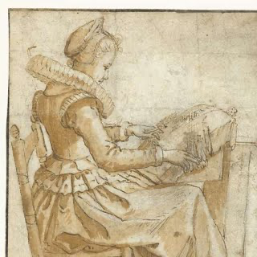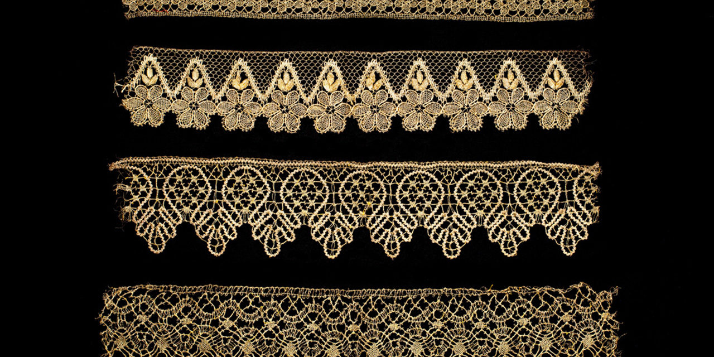

Traditionally, there are two methods of making lace. First, needlepoint, embroidering over set threads arranged in a pattern; second, bobbin lace. Bobbin lace is a type of lace made by the weaving of many individual threads attached to bobbins. The pattern is held in place by pins stuck in a pillow while the lacemaker braids and weaves the lace thread. It made for incredibly intricate, complex, fine lace, something very valuable in this period.

Textbook page 211

<https://www.metmuseum.org/toah/hd/txt_l/hd_txt_l.htm>

<https://fashionhistory.fitnyc.edu/pillow-bobbin-lace/>

Bombast - Esther Wambold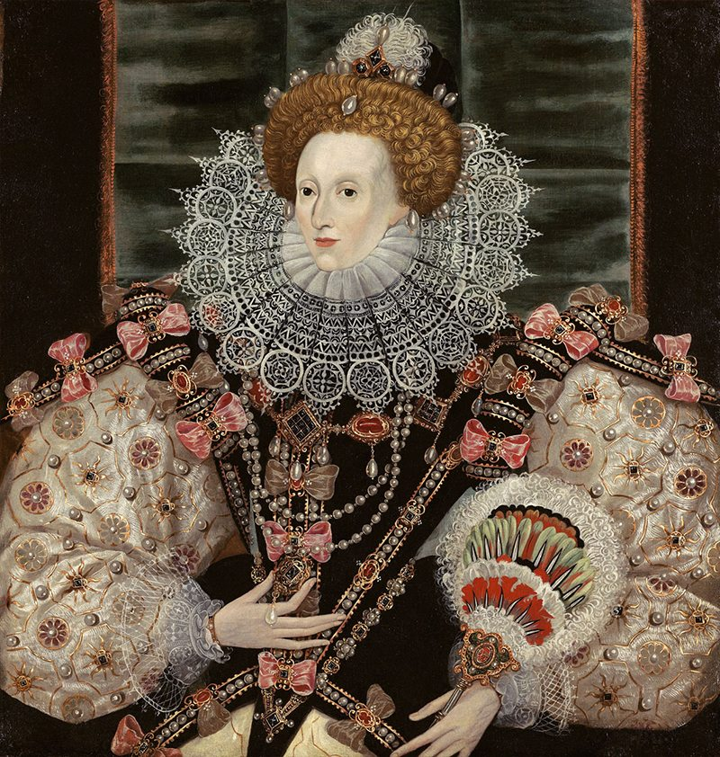

Bombast is a stuffing made of wool, horsehair, and short linen fibers. It was used to stuff garments like men’s hose and women’s sleeves. In this picture of Queen Elizabeth I, bombast is used to make her sleeves puffy.

Meng, S. (2018). *bombast/bombasted | Fashion History Timeline*. Fitnyc.edu. <https://fashionhistory.fitnyc.edu/bombast-bombasted/>

*Bombast-Curious Fashion History*. (2019). CHRISTIANNE BAKEWELL COSTUME DESIGN. <https://www.christiannebakewell.com/blog/bombast-curious-fashion-history>

Survey of Historic Costume pg. 213

Bum Rolls-Anna Ament

The Bum Roll was a form of padding tied around the hips that was used for the purpose of accentuating the hips and making the waist appear disproportionately small. At times it was even sewn into the gowns. It was worn underneath the clothing and often made of cotton or similar material. It did not extend around the entire waist in order to give the appearance of a larger behind. When looking at many portraits of the Renaissance time we can see the effects of the bum roll. Eventually, it became an essential part of female attire. 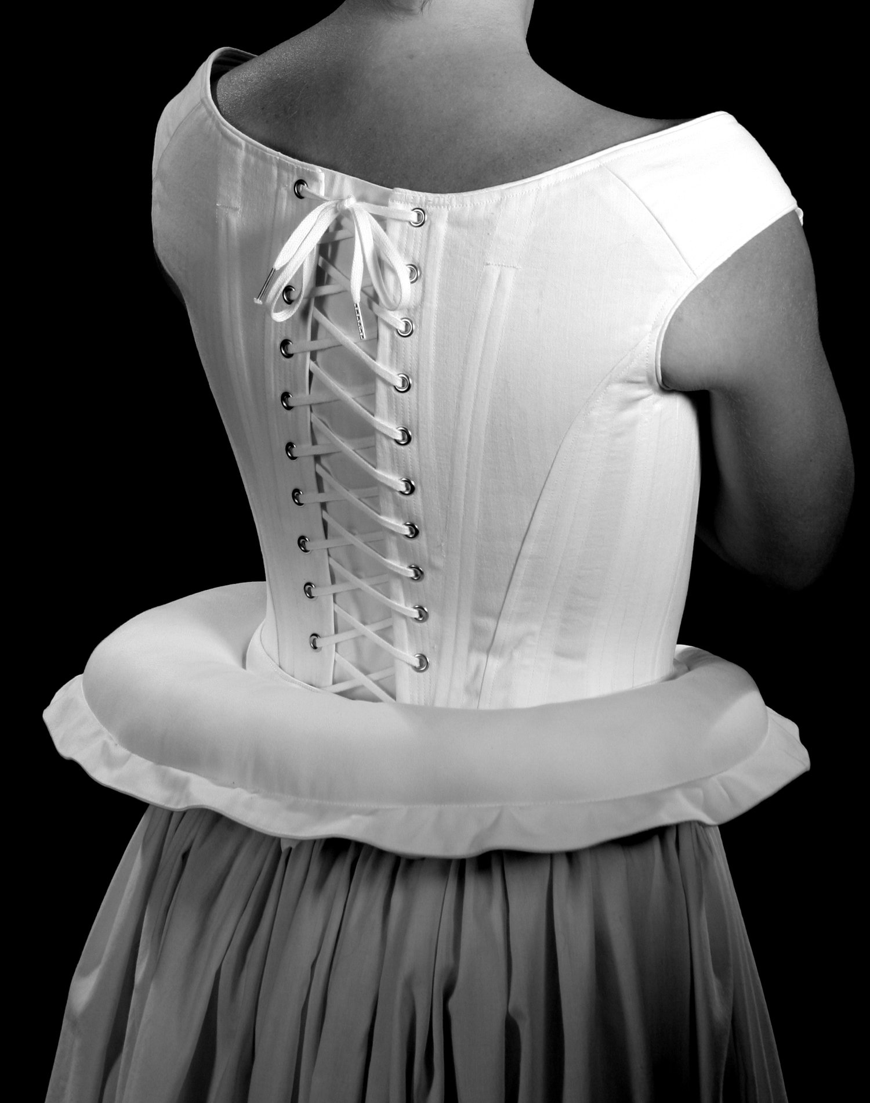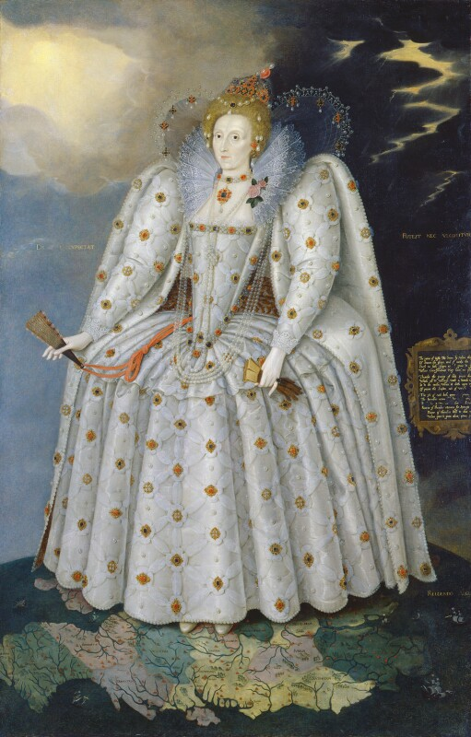

not sure if the B&W picture is necessarily accurate for the time, but it gives an idea of what the bum roll would have been like.

<https://fashionhistory.fitnyc.edu/bum-roll/>

[(Links to an external site.)](https://fashionhistory.fitnyc.edu/bum-roll/)

<http://www.elizabethancostume.net/bumroll.html>

Canions - Marisa Bone

Canions were tight, tubular garments which extended from the hem of Round Hose, Slops, or Trunk Hose, extending to the knee. Common in the second half of Queen Elizabeth's reign. Trunk hose were often worn with canions, a loose-fitting hose for the upper leg. An exaggerated form of trunk hose was known as pumpkin breeches. Made with contrasting vertical panels of fabric, these breeches ballooned outward, making it look as if the wearer had a large pumpkin about his waist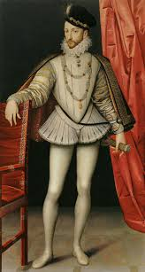

Trunk hose were often worn with canions, a loose-fitting hose for the upper leg. An exaggerated form of trunk hose was known as pumpkin breeches. Made with contrasting vertical panels of fabric, these breeches ballooned outward, making it look as if the wearer had a large pumpkin about his waist.

Sources [1](http://www.fashionencyclopedia.com/fashion_costume_culture/European-Culture-16th-Century/Hose-and-Breeches.html) and [2](http://www.tudorshoppe.com/Merchant2/renaissance_costume_glossary.shtml#:~:text=Canions%20(kan%2Dyens)%3A%20tight,half%20of%20Queen%20Elizabeth's%20reign.)

Book Pge 209

Copotain: Elizabeth Nathan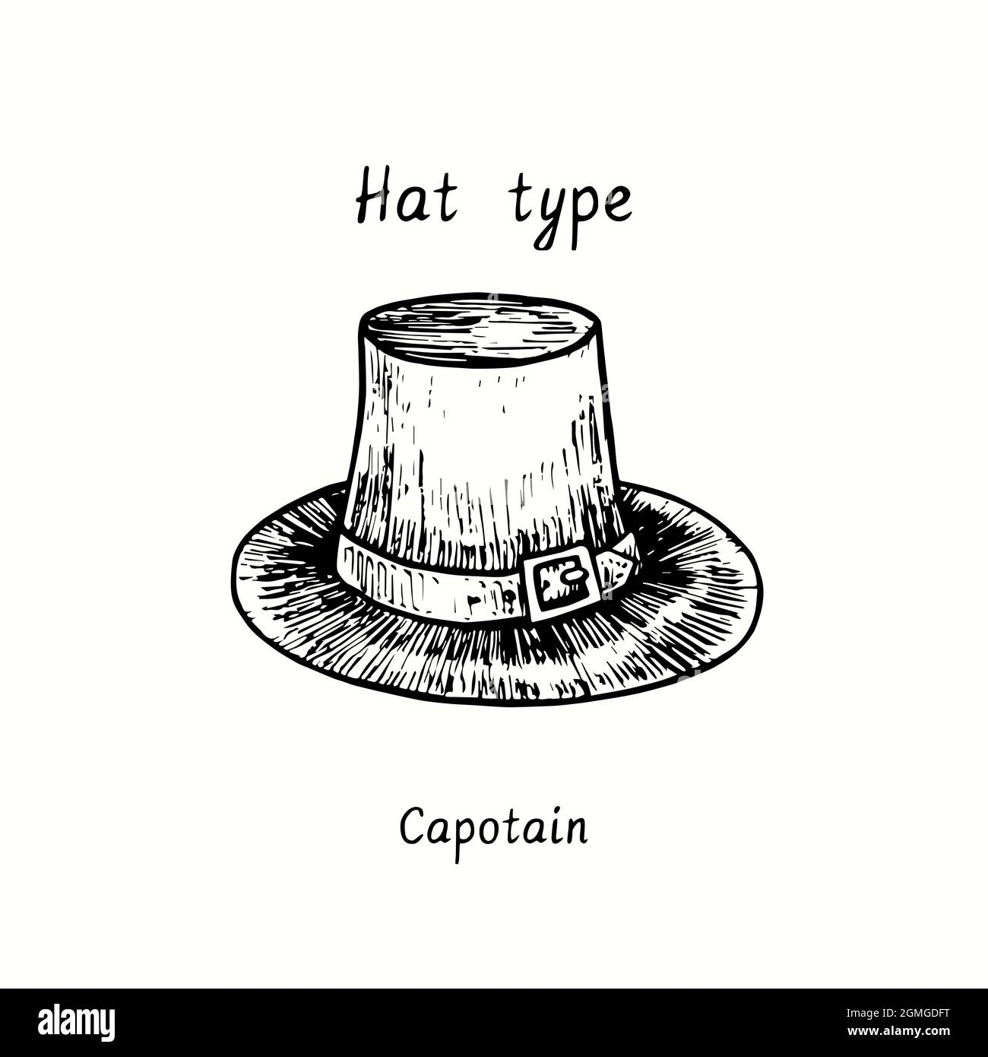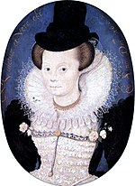

A capotain, capatain or copotain is a tall-crowned, narrow-brimmed, slightly conical "sugarloaf" hat, usually black, worn by men and women from the 1590s into the mid-seventeenth century in [England](https://en.wikipedia.org/wiki/England) and northwestern [Europe](https://en.wikipedia.org/wiki/Europe). Earlier copotains had rounded crowns; later, the crown was flat at the top.

Generally black in color and made of a thick felt, the copotain had a medium size brim, ranging between one and three inches, and a tall rounded crown. It was sometimes worn with a hatband, a band made of leather or fabric that ran around the crown just above the brim.

<http://www.fashionencyclopedia.com/fashion_costume_culture/European-Culture-16th-Century/Copotain.html#ixzz7KEIgQKba>

<https://en.wikipedia.org/wiki/Capotain>

Codpiece- Kimberly Tesam Moita

The Codpiece was a pouch of fabric that was sewn for the privates in the front of upper stocks. They were sometimes padded for emphasis, and later on looked different with later separate poofy garments (breeches) and were cut fuller than the lower section of stocks. Like the early renaissance, the codpiece was also very prominent and suggestive in shape, even decorated to call attention. Sometimes the codpiece also was a pocket or a pincushion, because of how it was made and padded. Later on there were even different variations of shapes in the *pluderhosen,* which was a rosette shaped codpiece on a pair of breeches.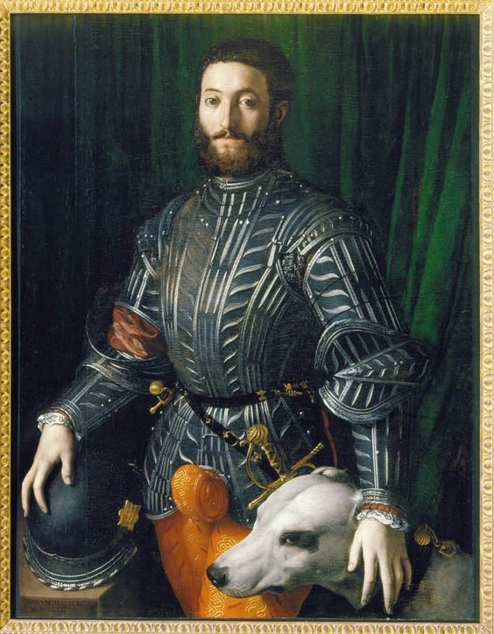

<https://fashionhistory.fitnyc.edu/codpiece/>

<https://www.newyorker.com/books/page-turner/a-brief-history-of-the-codpiece-the-personal-protection-for-renaissance-equipment>

<https://www.sothebys.com/en/articles/codpieces-style-on-the-rise>

Conch - Hannah Ferreira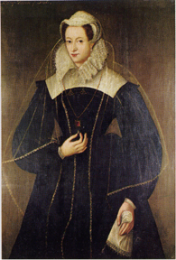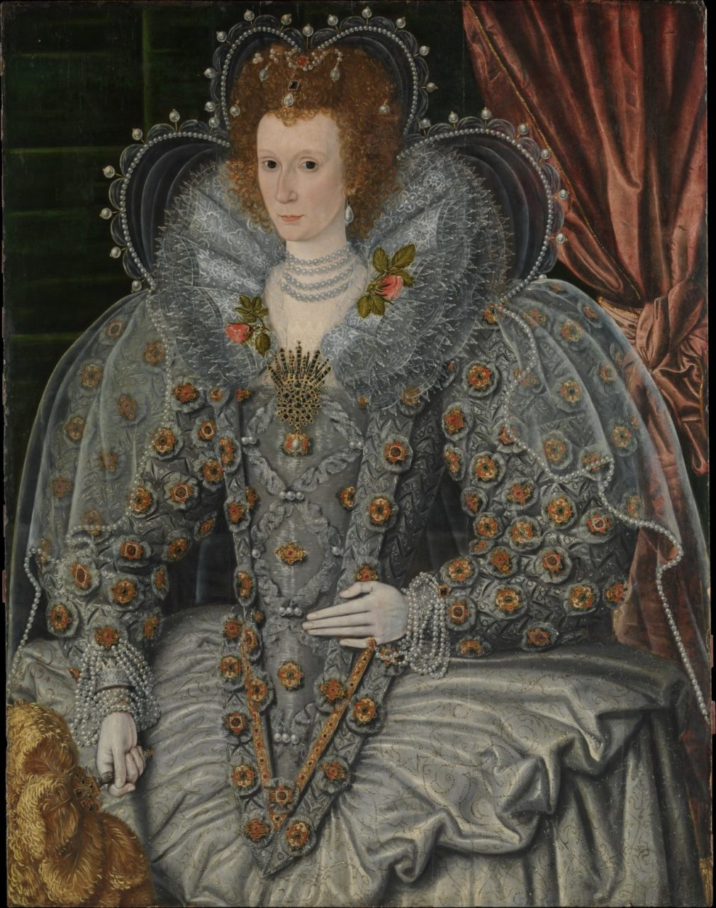

The conch was a sheer, gauzelike veil. It was cut the full length of the body from shoulder to floor and worn like a cape. It was thought that it might’ve only been something worn by widows, but because Queen Elizabeth was shown wearing one and she was never widowed, it must be that it was more commonly worn by all women.

Book

<https://fashionhistory.fitnyc.edu/1600-unknown-british-painter/>

<https://lowelldesigns.com/the-northern-renaissance/>

Culots- Bailey Pinder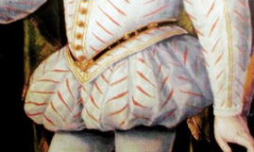

These were worn *only* in very fashionable circles. Culots were considered an extreme style.They were very short, basically just a pad around the hips, and worn with tight fitting hose. There is some debate as to whether it was found only in Elizabethan court and fashionable circles or if they were found in other areas of europe, such as italy, france, and spain

.<https://www.encyclopedia.com/sports-and-everyday-life/fashion-and-clothing/clothing-jewelry-and-personal-adornment/breeches>

<https://fashion-history.lovetoknow.com/clothing-types-styles/breeches>

The book, pgs 12-13

Duckbills- Ryann Becker

These were a type of shoes that became popular. No longer were pointed shoes in style. They had a square toe that continued to expand in width until they passed a sumptuary law that limited the width to 6 inches. Duckbills also had slashes with puffs of fabric being pulled through the openings. Later they became less extreme and just had fabric underneath the slashes and they were more conformed to the foot. 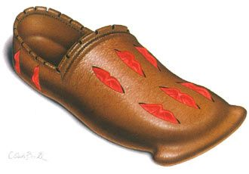

Textbook page 221 and 222

<https://fashionhistory.fitnyc.edu/1500-1509/>

<https://www.shoepassion.com/shoe-encyclopedia/shoe-history/middle-ages/>

Filet- Andrea Lazaro Hernandez

New decoration styles for clothing happened during the 16th Century. Filet lace or lacis was a technique to embroider patterns on a net. The design was made with a running stitch from side to side, and later tied on a knot similar to the fisherman knot. Filet lacing was originally made by hand, though it was later made by machines. 

Sources:

Survey of Historic Costume- p. 208

<https://www.britannica.com/art/filet-lace>

<https://trc-leiden.nl/trc-needles/regional-traditions/europe-and-north-america/embroideries/filet>

French Farthingale- Samantha Hooper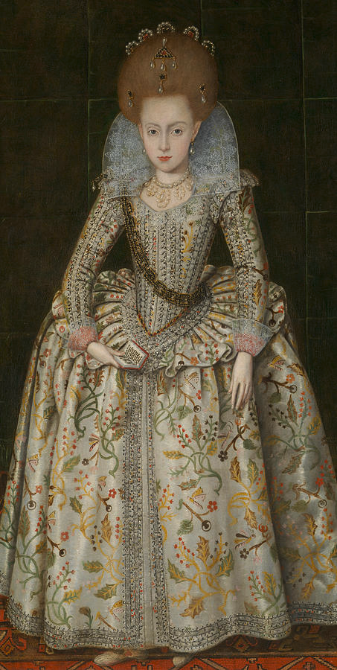

The French farthingale was a support of whalebone, cane, or steel hoops of the same diameter that were sewn into the skirt to make the skirt the same width from the top to the bottom. It is also called the wheel or drum. <http://nationalclothing.org/685-wheel-farthingale-or-french-farthingale-no-surviving-examples,-so-how-did-it-look-like.html>

http://elizabethanenglandlife.com/thetudorsfacts/tudor-spanish-farthingale-and-french-farthingale.html

Gabled Coif

Galligaskins and a full inner lining.

Lace - Irelynd Preece 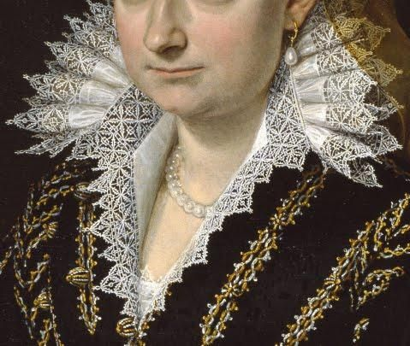

Lace was first developed in Europe during the sixteenth century. It is either cutwork or filet that is entirely constructed from any fine threads - including linen, silk, and cotton. It was very decorative and often the most costly part of the dress. During the sixteenth century, lace was worn by both men and women. However, once we get to the eighteenth century, lace became fully a woman characteristic.

Textbook page 208

<https://www.lofficielusa.com/fashion/lace-fashion-history-symbol-lingerie-chanel-fendi>

<https://www.sfomuseum.org/exhibitions/lace-sumptuous-history#:~:text=Lace%2C%20a%20decorative%20openwork%20web,Europe%20during%20the%20sixteenth%20century.&text=Both%20men%20and%20women%20wore,sophisticated%20tastes%20of%20the%20aristocracy> \.

Lacis

Medici Collar- Abigail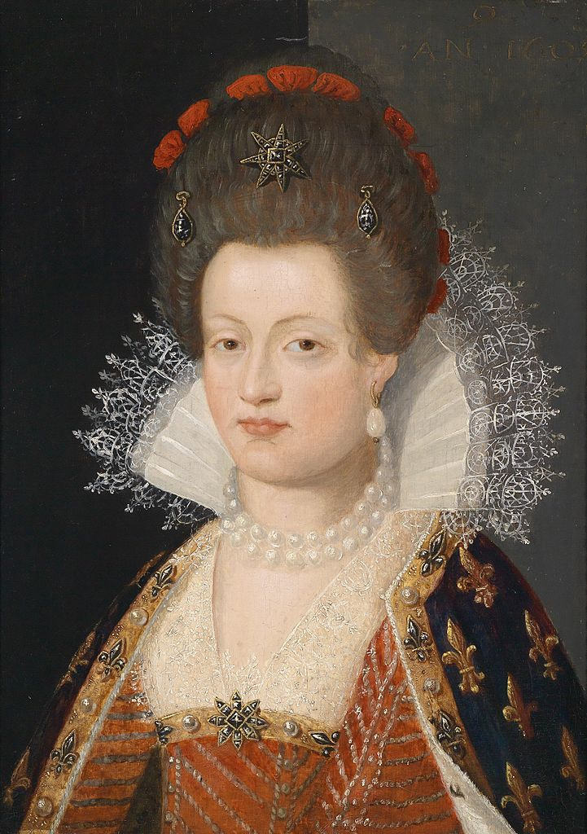

The medici collar is the name given to ruffs during the 18th and 19th century revivals of the style. However, it was different from the ruff in that it did not go all the way around the neck. They were made either by gathering lace together to the size of the neck or where “flat lace pieces without depth or fold” (Tortora, Eubank, pg 220). The fabric stood up behind the head and came around to the front where it opened up into the wide neckline. It was also supported by starch or wire.

Tortora, P. G., & Eubank, K. (2010). *Survey of historic costume: A history of western dress*. Fairchild.

<https://fashionhistory.fitnyc.edu/medici-collar/>

<https://www.encyclopedia.com/fashion/encyclopedias-almanacs-transcripts-and-maps/medici-collar>

Mules- Hailey Child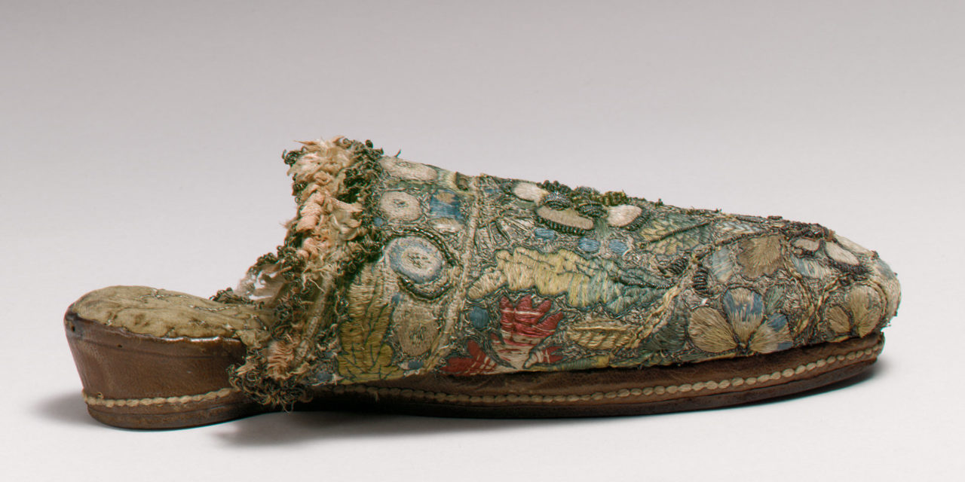

Mules are backless shoes or slippers worn by both men and women.The term mule actually derived from the Latin mulleus calceus, which meant the red slippers worn by Patricians. They started as indoor shoes, and shoes worn for comfort. Over time they have come in and out of style but mules are still worn even today! Mules were made with either round, square or forked toe shapes and with heels of heights from 1 ⅝ inches to 2 ½ inches. Many were embroidered for fashion but started very simple and not too elaborate until about 1850.

<https://fashionhistory.fitnyc.edu/mule/>

Book

<https://en.wikipedia.org/wiki/Mule_(shoe)>

Needlepoint Lace - Amanda Hair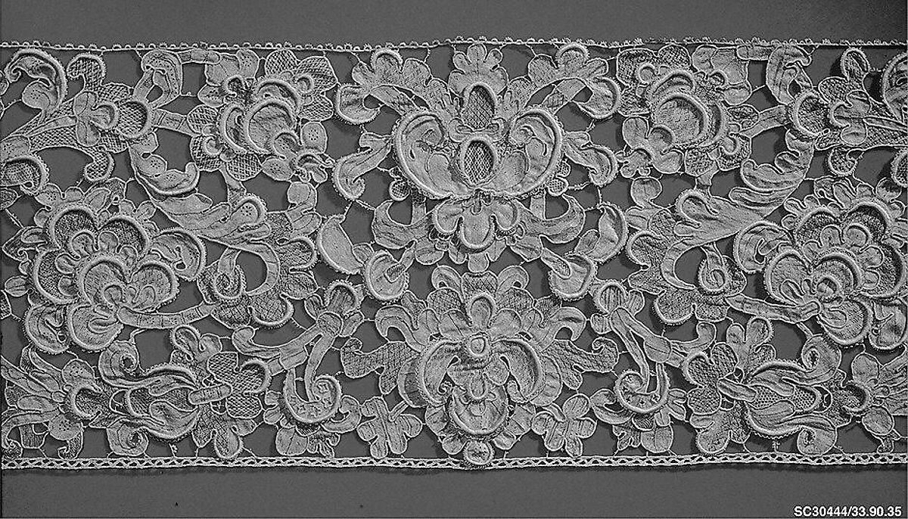

There are two ways to make this type of lace. One way is to use a needle to manipulate fine linen thread. The other is to use many threads attached to small bobbins. In Needle point lace you just use one single thread and make stitches that gradually build up the fabric. At this time in history lace fashions were changing dramatically. They went from being simple geometric styles to more 3D lace to a looser, more airy lace that was more of a decorated net. Italy was a main producer of these fine laces produced in the 16th and 17th century.

Textbook pages 205

https://www.metmuseum.org/toah/hd/txt_l/hd_txt_l.htm

<https://fashionhistory.fitnyc.edu/needle-lace/>

Nether Socks- Jalissa Cloward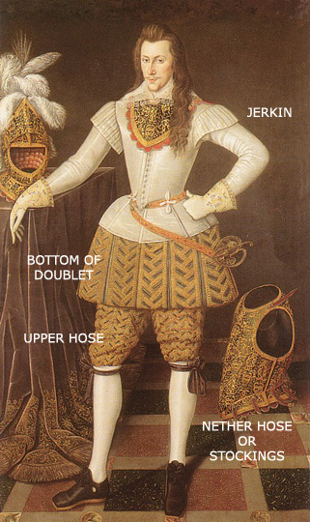

Nether socks were the bottom half of the two-piece hose. They were sewn to the upper socks or breeches.

*Survey of Historic Costume* pg. 211

<https://en-academic.com/dic.nsf/enwiki/1034597>

<http://costumehistorian.blogspot.com/2017/08/stockings-in-seventeenth-century.html>

Open Breeches-Brittany Pocock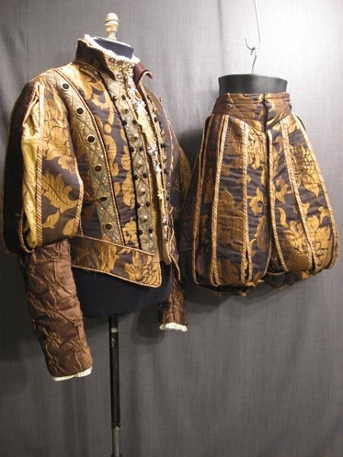

Breeches were a part of men's clothing they covered the body from the waist down. They closed around the leg along with open seams that varied in length. They were the standard of mens clothing but they stopped being used in the mid-19 century because of trousers. Although they have since been modernized for sports such as English riding or fencing.

[Men's Fashion During the Renaissance | LoveToKnow](https://mens-fashion.lovetoknow.com/Men%27s_Fashion_During_the_Renaissance)

[16th century costumes northern renaissance (slideshare.net)](https://www.slideshare.net/parul_prajapati/16th-century-costumes-northern-renaissance)

Book

Pair of Bodys- Jessica Fraser

This was equal to being a corset. It was worn on the outside of clothing and hugged the waist in tight. It was stiff and made you look tight. They didn't always look good so some were hidden. I thought it was interesting that Joan of Arc played such a big role and that it helped the French out. It is crazy that she was tried for livers.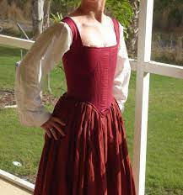

Sources:

<https://angelacostumery.com/2015/01/23/making-a-pair-of-bodies/#:~:text=%E2%80%9CBodies%E2%80%9D%20were%20the%2016th%20century,turn%20out%20very%20well!!>

<http://centuries-sewing.com/costumes/a-pair-of-bodies/>

The Book

Paltock- Savannah Tanner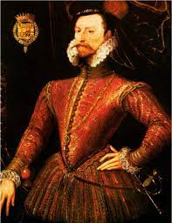

The Paltock was a doublet in England. It had a deep V cut in the front. Occasionally lace was used to hold areas and the sleeves together. Occasionally, you could see a Paltock layered with a jacket that was fashioned in a similar manner.

Pg. 209

<https://www.wordsense.eu/paltock/>

https://www.wordnik.com/words/paltock

Panes- Zaya Weight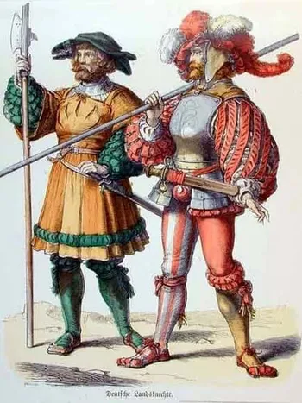

Panes are narrow strips of fabric sewn together over contrasting linings. They served essentially the same function as the slashing of outer fabrics to reveal contrasting linings underneath but it is less destructive. Actually cutting into fabric for the slashing effect can compromise the structural integrity of the textile & decrease the lifespan of the clothing, paning fixes this issue. Allegedly a swiss army in 1477 stuffed fabrics from banners, tents, & other looted fabrics into their torn & tattered clothes for warmth & that slashing & paning then caught on as an intentional decorative element of dress.

**Sources:**

Survey of Historical costume - page 210-211

<https://fashionhistory.fitnyc.edu/panes-paning/>

<https://blog.bridgemanimages.com/blog/cutting-edge-fashion-the-slashed-sleeve-in-early-modern-europe>

Petticoat (Part of outer garment) - Jocelyn Munoz

In the early 16th century petticoats were underskirts worn for warmth but as the century progressed it became known as garments worn by women under their gowns. In the 16th century petticoats were skirts—sometimes attached to a bodice that laced up in the front. Many petticoats were red as that was a very popular color. 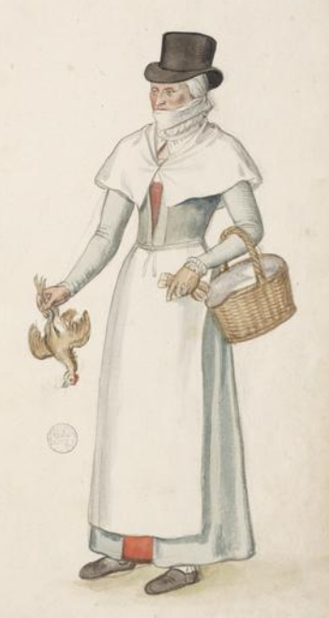

This woman is wearing a red petticoat it’s kind of just poking out.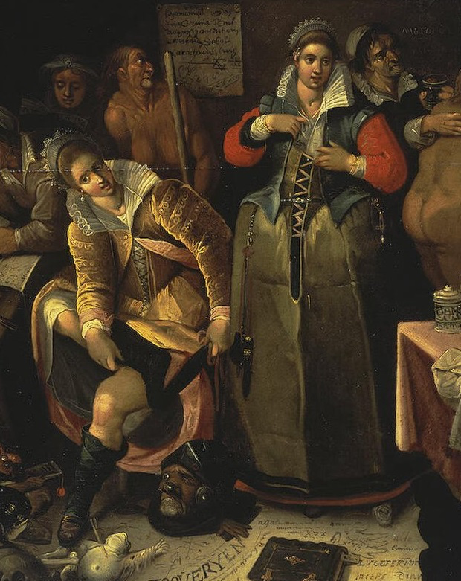

Tortora, P. G., & Marcketti, S. B. (2021). In Survey of historic costume. essay, Fairchild Books.

<http://www.elizabethancostume.net/petticoat.html>

<https://www.ilsegregoorcostumes.com/historic-costuming-basics-the-petticoat/>

Slops- Jamie Rakes 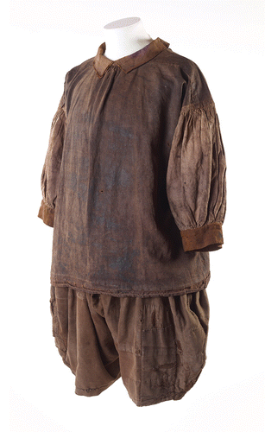

A slops is a garment that is worn loosely on the outside/ on top of other clothing. Usually made out of scrape cloth. This could be used for bedding or clothing.

As you can tell from the picture these garments were loose fitted and made out of leftover fabric. These slips were mainly at the bottom part of this set and were worn on top of the tights that men wore.

<https://www.collinsdictionary.com/us/dictionary/english/slops>

<https://www.pepysdiary.com/encyclopedia/6075/>

Spanish Farthingale - Savannah Jeppson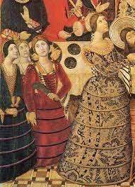

The Spanish Farthingale was Spain's take on farthingales. It was very similar, but instead of using a ‘wheel’ type support under the skirt, they would use a padded roll at the waist to obtain an hourglass figure. This style was also used in northern Europe along with the other types of farthingales. But in Spain, the French farthingale did not take popularity at the time and was mostly worn by the wealthy only.

Sources:

The Book

<http://www.elizabethancostume.net/farthingale/>

https://en.wikipedia.org/wiki/Farthingale

Stays - Aubrey Reidhead

Not to be confused with the preceding outer garment that was the corset, the stays were a pair of bodys that was rebranded into being a pair of stays. They’re still called this name today ([Silhouettes Costumes](https://silhouettescostumes.com/the-eras-we-build/stays-corsets-introduction-overview/)). The pair of bodys were divided into left and right sides and then either laced or taped together in front and back. (P.217) Lace bodices were worn under clothes that are fully boned. The name likely came from the French word “estayer” which means to support. The stays would support the bust, round out the torso, and provide a layering base for draping many layers of dress. This seems restrictive of motion to us, these were considered informal in comparison to dresses with boning built-in. ([The Dreamstress](https://thedreamstress.com/2013/08/terminology-whats-the-difference-between-stays-jumps-a-corsets/))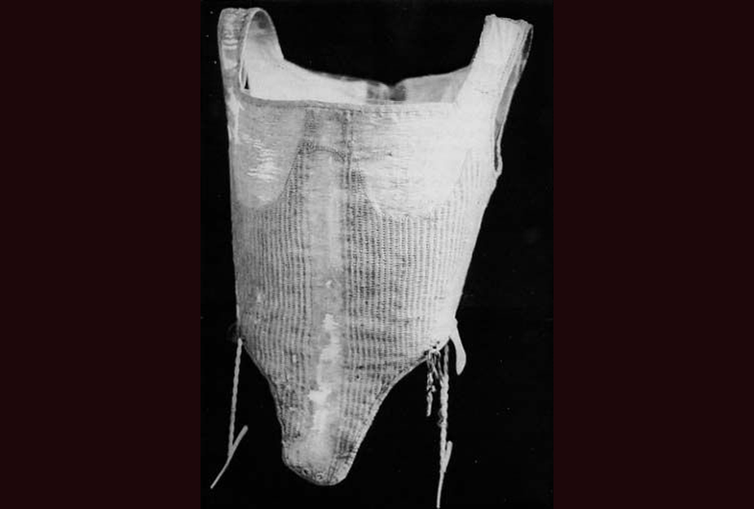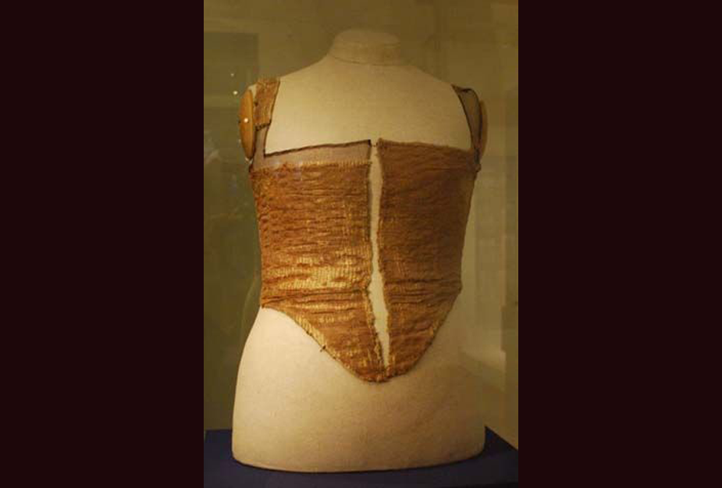

Stomacher- Lauren Shumway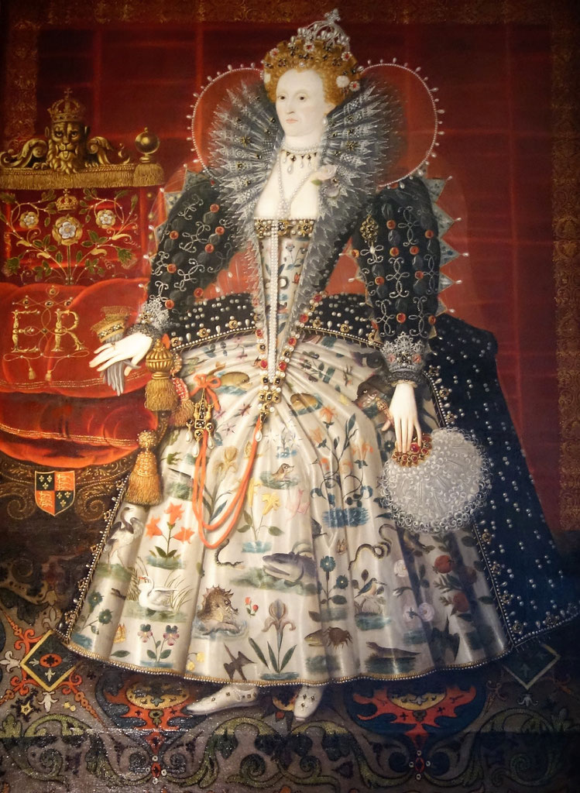

The stomacher was a part of womens dress from the 1570s to 1770s coming in a U shape or V shape. The stomacher was worn to close the front of dresses or a part of the bodice that could be removed to change the stomacher to match the petticoats being worn. Stomachers are also known as placards or plackets

Survey of Historic Costume. Pages 209,215

<https://fashionhistory.fitnyc.edu/stomacher/>

<https://en.wikipedia.org/wiki/Stomacher>

Supportasse- Ida Johnson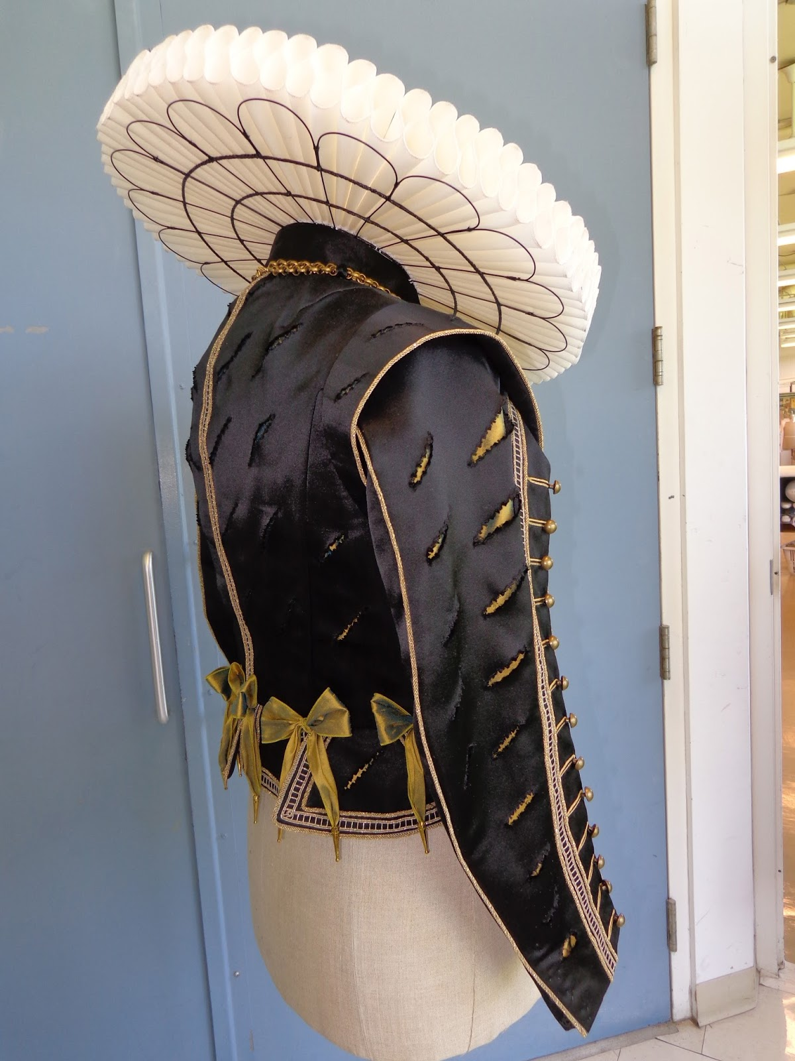

Ruffs along the necks grew to be so big that the weight would cause them to fall flat along the back. To keep them raised up and framing the head, a support system called the supportasse was installed. Starching could also be used.

<https://thepragmaticcostumer.wordpress.com/tag/supportasse/>

<http://costumehistorian.blogspot.com/2018/08/the-rebato.html>

Trunk Hose- Claire Moore- 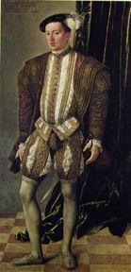

Trunk hose are a variation of breeches. They were attached to the bottom of the doublet with points or small ties and became puffy/ baggy before becoming tight on the upper leg. They were often worn with hose underneath them as well.

sources - <http://www.fashionencyclopedia.com/fashion_costume_culture/European-Culture-16th-Century/Hose-and-Breeches.html>

<https://www.encyclopedia.com/sports-and-everyday-life/fashion-and-clothing/clothing-jewelry-and-personal-adornment/hose-and-breeches>

Page - 212

Upper Stocks- Abbie Burns

The upper stocks are a part of the hose that men would wear. They tailed to the support of the hose in the upper portion of their legs. The upper stock was sewn together with the nether stocks. The upper stocks were sometimes padded at the crotch area to emphasize appearance. The upper stock would go from the toes to the waist, it became a common trend to wear them as two separate pieces. The upper and lower parts were attached at the knee. In the picture you can see where they are attached with a bow. This division of the hose adapted the name breeches or trunk hose. 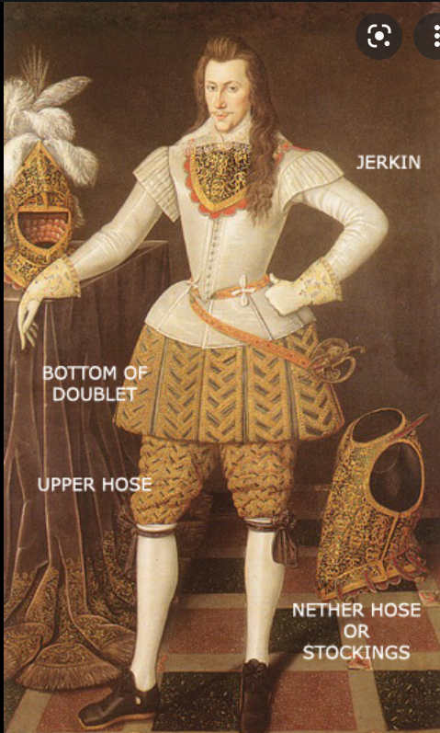

Book: page 211

<https://lowelldesigns.com/the-northern-renaissance/>

https://quizlet.com/119177382/history-of-costume-ch-8-flash-cards/

Venetians- Jensen Hepworth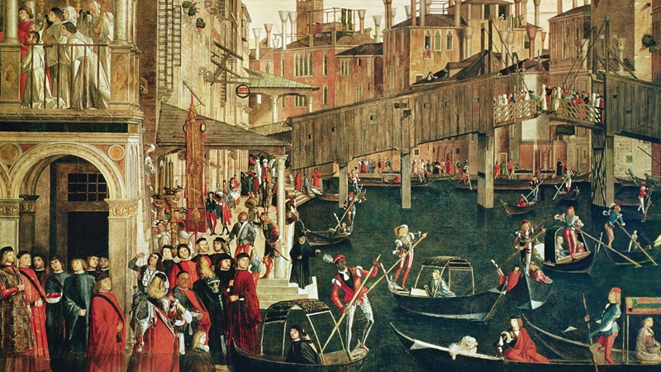

Venetians were those who lived in Venice. During the 16th century, the population of Venice was about 175,000 people. It was the first and largest trading power in the world.

The two prominent religions in Venice were the high class Catholics and the tread-upon followers of Judaism. There was a very established division, as Jews were walled off in the Ghetto at night time while the Christians were able to roam free.

<https://prezi.com/-icrgfa13gxr/venice-16th-cenutry-othello/>

https://serpent-of-venice.fandom.com/wiki/16th_Century_Venice

The book

Verdugale- Marisol Dejesus 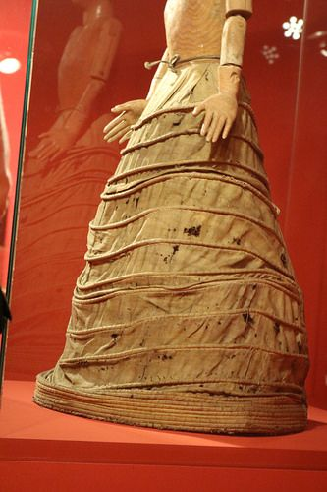

A verdugale is a Spanish device, but in Spanish is called verdugado. Verdugado means green wood or executioner. It was made of whalebone, cane, and steel hoop and was sewn into a petticoat or underskirt. The verdugale had a smooth hoop below the waist and larger hoop down the skirt.

Sources:

Book pg: 217 and 218

<https://en.wikipedia.org/wiki/Farthingale>

<http://www.fashionencyclopedia.com/fashion_costume_culture/European-Culture-16th-Century/Farthingales.html>